PRAYING WITH THE LONG SUFFERING
compiled by Sister Eileen McNerney, csj
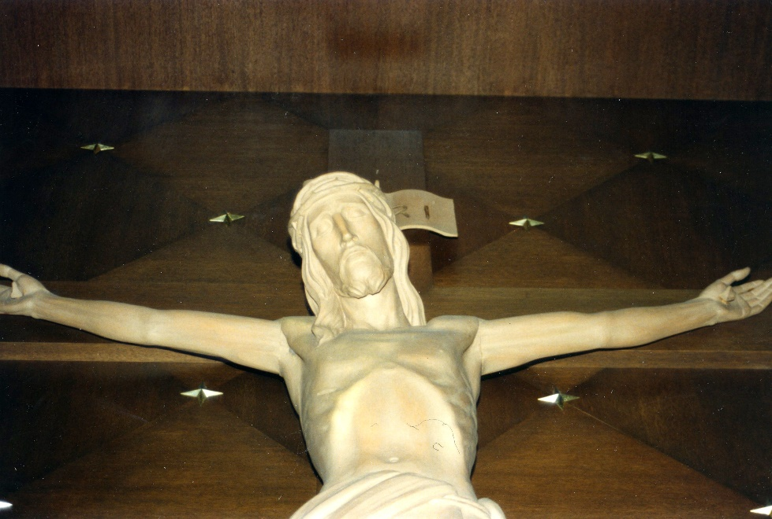
Thus says the Lord,
Who created you, Jacob, and formed you, Israel:
Do not fear, for I have redeemed you;
I have called you by name: you are mine.
When you pass through waters, I will be with you;
Through rivers, you shall not be swept away.
When you walk through fire, you shall not be burned,
Nor will flames consume you.
For I, the Lord, am your God.
You are precious in my eyes and I love you. Isaiah 43: 1-2, 4

I hope that these prayers and reflections may be helpful to you and to those you know who are dealing with the challenges and anxiety of living with chronic illness or physical diminishment. Those I visit often tell me that they feel they no longer know how to pray, and that they fear they’re letting God down. I share the following guidance from St. Francis de Sales with them – works for me, very often helpful to others as well.

When you come before the Lord, talk to Him if you can.
If you can’t, just sit there.
Let yourself be seen.
Don’t try too hard to do anything else.
St. Francis de Sales

Prayer of Abandonment
Father,
I abandon myself into your hands;
do with me what you will.
Whatever you may do, I thank you:
I am ready for all, I accept all.
Let only your will be done in me,
and in all your creatures –
I wish no more than this, O Lord.
Into your hands I commend my soul:
I offer it to you with all the love of my heart,
for I love you, Lord, and so need to give myself,
to surrender myself into your hands without reserve,
and with boundless confidence,
for you are my Father. -Blessed Charles de Foucauld

THE PRAYER OF OPEN HANDS
It can be hard to sit with one’s hands open before the Lord – letting God have full access to one’s life and to what one may be attached. Here is my attempt to do so:
You have given me all, God. Is there anything now that you want to ask of me? Here --- take it -- my time, my plan for my life, for the next six months, even for tomorrow. Is there anything that I cling to that prevents me from giving my all to you? Take it. I prefer to keep my hands clasped around that which pleases and comforts me most. Keeping my hands open before you, God, is a profound act of TRUST. And, is there anything that You would like to give to me? Any grace that You believe I am in need of? I ask You to give me that grace as a gift of Your love.
All is GIFT. All has been given to me by You. I ask for the grace to open my hands and my life before You, God, in complete TRUST and with great Love and Joy.
-based on a reflection by Sister Eileen McNerney,csj

A MEDITATION OF JOHN HENRY CARDINAL NEWMAN

God has created me to do him some definite service;
He has committed some work to me which he has not committed to another.
I have my mission. I may never know it in this life, but I shall be told it in the next.
I am a link in a chain, a bond of connection between persons.
He has not created me for nothing. I shall do good. I shall do His work.
I shall be an angel of peace, a preacher of truth in my own place while not intending it
if I do but keep His commandments.
Therefore, I will trust him. Whatever, wherever I am, I can never be thrown away.
If I am in sickness, my sickness may serve him;
in perplexity, my perplexity may serve him;
if I am in sorrow, my sorrow may serve him.
He does nothing in vain. He knows what he is about.
He may take away my friends. He may throw me among strangers.
He may make me feel desolate, make my spirits sink,
hide my future from me. Still, He knows what he is about.
John Henry Cardinal Newman

MOVING TOWARD BLESSED SURRENDER

When the signs of age begin to mark my body . . . and still more when they touch my mind . . .
When the ill that is to diminish me or carry me off strikes from without or is born within me . . .
When the painful moment comes in which I suddenly awaken
to the fact that I am ill or growing old . . .
At that moment, when I feel I am losing hold of myself,
and am absolutely passive within the hands of the great unknown forces that have formed me . . .
In those dark moments, Loving God,
grant that I may understand that it is YOU
who are painfully parting the fibers of my being
in order to penetrate to the very marrow of my substance and bear me away within yourself.

based on a prayer by Pierre Teihard de Chardin, SJ

CARRYING THE CROSS

Jesus, grant me strength to carry your cross . . .
† On those days when life seems demanding with all its cares, burdens, and concerns . . .
† When I experience loneliness deep inside and the pain of separation fills my spirit . . .
† When I feel the pain of our world and unite in compassion with the Earth’s suffering people
† When I struggle with decision-making and the time comes to make important choices . . .
† When I am with others in their physical pain or when I visit with one who has a terminal illness . . .
† When I am asked to go the extra mile, to be generous with my time and my presence . . .
† When I feel weary and worn out, when it seems like my energy has been drained away . . .
† When I am challenged to risk my security and to accept new growth in my relationship with you . . .
† When I experience the effects of aging or extended illness on my body or my mind . . .
† When I feel discouraged, desolate, and depressed and want to withdraw from others . . .
† When worries and concerns choke my peacefulness and leave me with anxiety and fear . . .
† When I harbor old wounds and am called to offer or to receive forgiveness . . .

Jesus, help me to take up my cross day by day. Through these crosses, I can grow closer to you. Help me to lean on you and to learn from you. May I not give in to self-pity or self-doubt. Rather, let me trust in your presence which strengthens me. Encourage me on my tomb-like days. Remind me of your resurrection. Help me to keep my vision focused on life and growth. Amen.

ANIMA CHRISTI
Jesus, may all that is in you flow into me.
May your body and blood be my food and drink.
May your passion and death be my strength and life.
Jesus, with you by my side enough has been given.
May the shelter I seek be the shadow of your cross.
Let me not run from the love which you offer.
But hold me safe from the forces of evil.
On each of my dyings shed your light and your love.
Keep calling to me until that day comes.
When with our saints, I may praise you forever. Amen
-a reflection by David Fleming, SJ

WHEN THE HOLY THAWS

A woman’s body, like the earth, has seasons;
when the mountain stream flows,
when the holy thaws,
When I am most fragile and in need,
it was then, it seemed, God came closest.

God, like a medic on a field, is tending our souls.
Our horns get locked with desires, but don’t hold yourself
too accountable; for all desires are really innocent.
That is what the compassion in His eyes tell me.

Why this great war between the countries – the countries inside of us?
What are all these insane borders we protect?
What are all these different names for the same church of love we kneel in together?
For it is true, together we live;
and only at that shrine where all are welcome will God sing loud enough to be heard.

Our horns got locked with the earth and sky in some odd marriage ritual;
So what, don’t worry. We should be proud of ourselves
for everything we helped create in this magic world.
And God is always there, if you feel wounded. He kneels
over this earth like a divine medic, and His love thaws the holy in us.
St. Teresa of Avila
(Love Poems from God: Twelve Sacred voices from the East and West)

WHAT CANCER CANNOT DO

Cancer is so limited...
It cannot cripple love
It cannot shatter hope
It cannot corrode faith
It cannot destroy peace
It cannot kill friendship
It cannot suppress memories
It cannot silence courage
It cannot invade the soul
It cannot steal eternal life
It cannot conquer the spirit. - author unknown

HEALING PRAYER AT BEDTIME

Lord Jesus, through the power of the Holy Spirit,
Go back into my memory as I sleep.
Every hurt that has ever been done to me, heal that hurt.
Every hurt that I have ever caused another person, heal that hurt.
All relationships that have been damaged in my whole life
That I am not aware of, heal those relationships.
But, O Lord, if there is anything that I need to do,
If I need to go to a person because he or she is still suffering from my hand,
Bring that person to my awareness.
Remove whatever bitterness may be in my heart, Lord,
And fill the empty spaces with your love. Amen
-Author unknown

Psalm 23
Psalm 139

