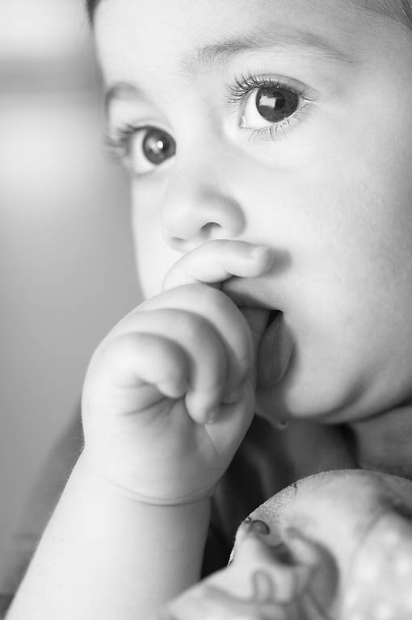
Spiritual Adoption Program
On January 22, 1973, the Roe vs. Wade Supreme Court decision was rendered which legalized abortion throughout the entire nine months of pregnancy. Since that time, more than 50,000,000 (50 million) babies have died by surgical abortion. Did you know a baby dies by surgical abortion about every 20 seconds in the United States?
To help stop the anti-life push around the world, the late Archbishop Fulton J. Sheen encouraged the spiritual adoption of an unborn child. This is done by praying that the one particular but unknown child’s life be spared abortion and be allowed to continue to live.
The Spiritual Adoption Program has three elements:

- It is an opportunity to pledge a daily prayer for nine months for a baby who is in danger of abortion. This special prayer is found on the Spiritual Adoption Prayer cards. For the parents of the baby, please pray a daily Hail Mary. Pray that God in His great mercy will grant the parents the courage to once more imitate the lives of Mary and Joseph. They gave a humble yes to bring forth the life of Jesus, our Savior, in a way that was defiant to the wisdom of their time.

- It is an opportunity to educate others about the development of the pre-born baby. You also are encouraged to put an article in your parish bulletin once a month so that all can watch the progress of their baby’s development.

- At the end of nine months you might like to host a baby shower. The baby shower is a visible means of imitating the Magi by providing assistance in the form of a donated baby item. These baby items can be given to one of the Respect Life Clinics, Centers or Shelters.
On the day you launch the project, each parishioner participant should be given something on which to write the name of their spiritually adopted baby. (For instance, some parishes have used pink or blue cards or cut-out of a baby item, i.e., a small 2-3 inch paper baby bib. We have gone to a scrapbooking store and used the diecuts to make pink and blue baby bibs. The cards or other cut-out baby item may be attached to a “Tree of Life.” (Some parishes make a tree using tree branches or a banner can be used to which you attach the names of the babies.)
The “Tree of Life” banner with the names of all the spiritually adopted babies is displayed one Sunday each month (with a corresponding baby development bulletin announcement – bulletin announcements follow).
Our prayers CAN make a difference between whether a baby will be born ... or aborted. Our prayers can also be a form of spiritual support for both of the parents. Please share the love of life given to you by the Lord of all life and join in spiritually adopting a baby.

SPIRITUAL ADOPTION PROGRAM
BULLETIN ANNOUNCEMENTS

(Two weeks before the program is to begin)

Everyone loves the beauty and innocence of a baby. As an expression of that love, (insert the name of the parish) announces an adoption program for young and old alike.

The members of (insert name of parish) parish family will have the opportunity next weekend to “spiritually” adopt a child who is newly conceived this month. Not all newly conceived babies are allowed to be born. In fact, more than 4,000 babies lose their lives to abortion each day. It is these babies you are being asked to “adopt”.

You may “adopt” a child individually or as a family by signing up during the weekend of (give date). You will be asked to name the child for whom you will be praying, thereby giving the baby the humanity he or she deserves. You will be asked to pray for your unborn child and for all unborn children, for the power of prayer is great.

You will receive monthly reports through the parish bulletin describing your baby’s development and your child will be born in (give month).

There are millions of unborn babies desperately in need of your prayers. Won’t you please “spiritually adopt” one and share the love for life that God have given you?

MONTH ONE – Developing Baby Spiritual Adoption Program

“My heart started beating today!” During this first amazing month of life, the baby grows to 10,000 times his size at conception. He is totally dependent upon his mother. Between mother and child lies the vital organ called the placenta. Here vessels from mother and baby intertwine without joining, highlighting this newly formed relationship – mutual, nourishing and deeply connected. By the third week the baby’s tiny hart begins to beat. Pray that the Lord of Life might move the heart of the baby’s mother to give him the most precious gift of all - - the gift of life.

MONTH TWO – Developing Baby Spiritual Adoption Program

“I can suck my thumb now!” The developing baby is now called a “fetus” (Latin for “little one”). She is making rapid progress developing all her external and internal organs. During the second month baby teeth form, and fingers and toes are developing. Her ears, nose, lips and tongue can now be clearly seen. Brain waves can be recorded. The skeleton changes from cartilage to bone. The central nervous system is now functioning, and so forty muscle sets begin their first exercises. By 8 weeks all body systems are present. This little one can now suck her thumb and is about two inches long. Thank you for praying for this precious little baby!

MONTH THREE – Developing Baby Spiritual Adoption Program

“I grabbed my hand!” The baby can now squint, swallow and move his tongue. He sleeps and awakens. Fingernails and toenails form and he now has his own unique set of fingerprints. Sensitive to touch, he will tightly grasp an object placed in the palm of his hand. He breathes amniotic fluid to help develop and strengthen the respiratory system, but he gets the oxygen he needs through the umbilical cord. The baby you are praying for weighs one ounce and is about 3 inches in length.

MONTH FOUR - - Developing Baby Spiritual Adoption Program

“I had a dream!” Your baby’s brain has begun maturing – a process that will continue until she is about 14 years old. Her eyelids are now sealed and will re-open at 7 months. Her taste buds are now working. Nutrients consumed by her mother are passed on to her within an hour or two. Three hundred quarts of fluid a day are sent to the baby via the umbilical cord. Fine hair begins to grow on head, eyebrows and eyelashes. Facial expressions similar to parents of the baby can be seen at this time. This month REMS (rapid eye movements) have been recorded – a sign of dreaming. Your baby is now about 9 inches in length. Thank you for praying!

MONTH FIVE – Developing Baby Spiritual Adoption Program

Your spiritually adopted baby weighs over one pound now. His mother can feel his movement now. Before, he was too small for her to feel. Although he swam with ease in his watery world, he needed to be big and strong enough to kick hard against the outside wall and dent it - - the inside wall of the uterus has no feeling. We are mid-way through the pregnancy now. He is about 12 inches in length. Your prayers have helped your baby’s mother continue with her pregnancy and seek the help she needs.

MONTH SIX – Developing Baby Spiritual Adoption Program

“I’m sitting up straight now!” The baby’s oil and sweat glands are functioning; these help regulate body temperature. A white filmy layer covers the baby and protects her delicate skin from the surrounding amniotic fluid and from scratches as she twists and turns. This waxy substance will be quickly absorbed into her skin soon after she is born. She can now respond to a sound. Her lungs are fairly well developed and she would stand a good chance of survival if born at this time. Her weight is approaching two pounds and she is about 14 inches long. Thank you for praying!

MONTH SEVEN – Developing Baby Spiritual Adoption Program

“I can look around!” Beginning this month the baby uses all four senses. His eyelids open and close and the eyes look around. The baby can hear, taste, touch, cough, yawn and hiccup. He now recognizes his own mother’s voice. His grip is even stronger now than it will be after his birth. The hair on his head is growing longer and the downy covering on the rest of his body is disappearing. During this time the baby will receive antibodies from his mother providing him immunity to a wide variety of diseases. He is about 15 inches in length. Thank you for praying!

MONTH EIGHT – Developing Baby Spiritual Adoption Program

“I like to listen to my Mommy’s voice!” In the last two months the baby continues to gain weight. She is developing a layer of fat that will keep her warm after she is born. In the 9th month she will shift to a head-down position, preparing for birth. Her lungs are now fully developed and capable of making the transition to breathing air. After birth she will continue the human growth process for many years to come. She is about 18 inches in length. Your baby’s mother appreciated the prayers you have said for her and her baby throughout the pregnancy. It has not been easy, but your prayers have given her the grace she needed to bring her baby to term.

MONTH NINE – Baby is Born Spiritual Adoption Program
“Here I am!” Your spiritually adopted baby was born this month - - nine months after his/her mother conceived him/her. The only change at birth is a change in the external life support system of the baby. He/she is no different now than he/she before birth except that he breathes and eats differently. He/she is truly a miracle. He began as a 46-chromosome cell and has developed over the past nine months into this unique human baby. Never before in history, nor ever again, will anyone exist that is just like your spiritually adopted baby. Your prayers saved his/her life. Thank you on behalf of all of the little babies that you cared enough to pray for him/her and his/her mother. . HAPPY BIRTHDAY BABY!

